**HDMI 2.0 Optical Transceiver**

**Description**

HDMI 2.0 optical transceiver is a high-performance, low power consumption. The HDMI optical transmitter and receiver at two sides can be detachable from fiber cable with LC interface.

The fiber cable is multi-mode single fiber cable, which is mainly to transmit high-speed data signals and can transmit high resolution, lossless 4K444@60Hz ultra-high-definition video directly. The maximum transmission range is 300m, using a multi-mode single fiber LC-LC patch cord.

It is widely used in a/v projects related to theme park, museum, exhibition room, control room, conference room, etc.

**Features**

* high speed fiber optics
* HDMI signal pass-through with COB and WDM technology, no protocol conversion required
* 300m long distance extension without signal loss
* EMI & RFI resistance
* It’s suitable for a/v devices connectivity with HDMI interface, such as player, TV, Computer, Projector, etc.
* Supporting EDID, ARC, CEC, HDCP2.2, HPD, etc.
* Both Tx and Rx need power supply.

**Connection Diagram**

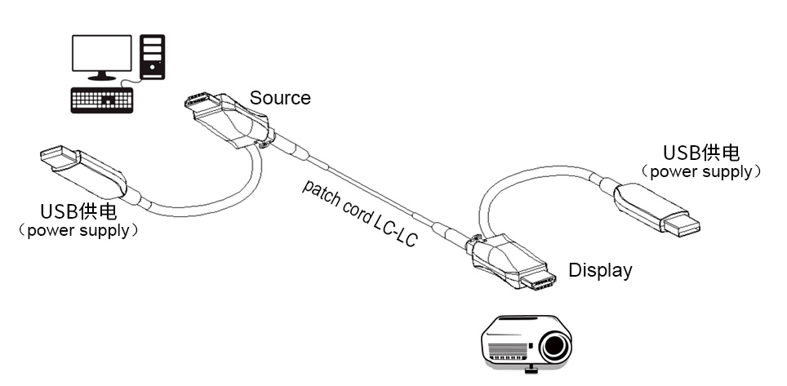

**Parameters**

|  |  |
| --- | --- |
| **Performance** | |
| HDMI version | HDMI 2.0 |
| Data Rate | 18Gbps |
| Video Resolution | 4K444@60Hz, backwards compatible |
| **Interface** | |
| HDMI connector (Source /Display) | HDMI Type A male |
| Fiber connector(Source /Display) | single fiber LC |
| Power supply(Source /Display) | Micro USB2.0 |
| **Cable** | |
| Cable | Patch cord |
| Cable Specification | Armored Multimode single fiber 850nm OM3 50/125μm, LC-LC |
| Length optional | 1-300meter |
| **Environment** |  |
| Working Temperature | -20℃~+70℃ |
| Storage Temperature | -40℃~+70℃ |
| **Power** |  |
| Voltage | +5V |
| Power Consumption | Source<800mW; Display<400mW |
| **Dimension** |  |
| HDMI optical transmitter | 45.35*20.5*12.5(mm) |
| HDMI optical receiver | 45.35*20.5*12.5(mm) |

**Ordering Information**

|  |  |  |  |  |
| --- | --- | --- | --- | --- |
| **Part No.** | **Specification** | **Connector** | **Length（m）** | **Color** |
| MMF4K60-TX | HDMI2.0 optical transmitter, 18Gbps 4K@60Hz | HDMI type A male- type A male | / | black |
| MMF4K60-RX | HDMI2.0 optical receiver, 18Gbps 4K@60Hz | HDMI type A male- type A male | / | black |
| LCPC-LCPC-OM3-3-XXM | Armored 850nm Multimode single fiber patch cord | LC-LC | 1-300m optional | blue |