SuperSlimHDbaseT 70/100

User Manual

SSH70/100-T (Transmitter)
SSH70/100-R (Receiver)

4K HDBaseT Extender
SSH70: 70m @1080p or 40m @4K
SSH100: 100m @1080p or 70m @4K
SSH70/100 supports:
HDMI 2.0, Test Pattern, Down-Scaler, EDID & HDCP control,
Audio de-embedded, CEC & Temperature control, diagnostics, iPoC

Contents
Features 4
Connectors and Controls 4
Front 4
SSH70/100-T 4
SSH70/100-R 4
Rear 5
SSH70/100-T 5
SSH70/100-R 5
Using the SSH70/100-T and SSH70/100-R 6
RJ-45 Wiring 7
Test Pattern and Keep-Alive Features 7
Down-Scaling 7
Connecting to the IR Ports 7
RS232 Control Commands 8
SSH70/100-PCTools 8
HELP Command 8
Input HDCP Command 8
Output HDCP Command 9
EDID Commands 9
4K Down-Scaling 9
Video Keep Alive (No Signal Handling) (Timed) 10
Test Pattern 10
Safety Temperature 11
Diagnostic Commands 11
CEC Commands 12
Automatic CEC Display Control 13
TX POC Commands 13
RX POC Commands 13
Specifications 14
General 14
Video and Audio 14
Power Supply 15
Environmental and Physical 15
Package Contents 15

Thank you for purchasing the SSH70/100 Extender Set.
This HDBaseT extender is designed with the professional AV installers in mind. The many extensive features assist in system integration, validation and maintenance. It is still the slimmest HDBaseT extender in the world with tremendous flexibility and extraordinary capabilities.

Installation precautions
This product has special circuitry to protect it against moderate surges and static discharges. However, to ensure reliable operation and long service life, it is important to take the necessary precautions against any spikes, surges and static discharges.
Place the units away from heat sources and allow adequate ventilation.
Shielded cable and in particular cat6, cat6a or cat7 is highly recommended. As much as possible cables should be routed away from any noisy sources and avoiding long runs in close proximity to mains cables.

The SSH70/100 HDBaseT Extender set supports all input resolutions to 4K60 4:4:4, with bi-directional IR, and two independent pass-through RS232 ports. The main RS232 channel (Tx/Rx) is also used for controlling the many features. The second RS232 channel (T2, R2) can also be used for RTS/CTS handshaking.
The transmitter unit (SSH70/100-T), also supports de-embedded audio (L/R and Mini-Toslink optical output), as well as many useful features such as: HDCP management, EDID settings, video Down-Scale, Test Patterns, Video Keep Alive, Temperature & CEC control, diagnostics.

Features
- HDMI input supports up to 18G HDMI 2.0 (4K60 4:4:4)
- Transmission length
SSH70: up to 70m @1080p, or 40m @4K
SSH100: up to 100m @1080p, or 70m @4K
- Many features: Test Patterns, 4K down-scale, Video Keep Alive, CEC control, etc.
- Extensive EDID and HDCP control
- Over-temperature control and protection
- Audio extraction to Mini-Toslink and 3.5mm L/R outputs (Transmitter unit)
- Bidirectional IR and two independent RS232 ports
- SSH70/100-PCTools: For easy control and diagnostics of enhanced features
- iPoC safely provides power to both units using a single 48V PSU

Connectors and Controls

Front

SSH70/100-T
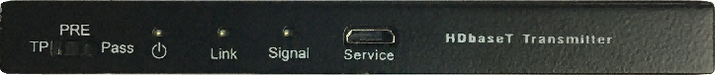

SSH70/100-R

Name | Description
EDID Switch  (SSH70/100-T) | - TP: Generate a Test Pattern (RS232 command configurable).  Default Test Pattern is Chequerboard at 1080p  - PRE: Pre-defined HDMI input EDID.  There are 22 EDID options selectable from RS232 commands.  Default pre-define EDID is 4K60 (4:4:4) 2.0CH  - Pass: Use the EDID data from the display device.
Power LED | Lit when the unit is powered
Link LED | Lit when the HDBaseT Transmitter and Receiver are linked together
Signal LED | Lit when there is video signal transmission through HDMI cable
Service port | Used for firmware updating (do not use as a USB port)

Rear

SSH70/100-T
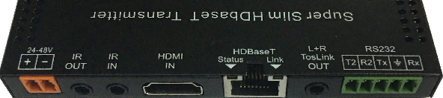

SSH70/100-R
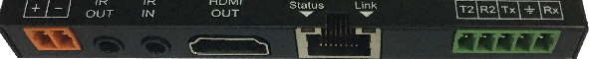
Name | Description
24-48V | Two way 3.5mm phoenix connector. 24 to 48V supply input
IR OUT | IR output – Connect to IR emitter
IR IN | IR input – Connect to IR eye
HDMI IN | HDMI input from external source
HDMI OUT | HDMI output to display
HDBaseT | HDBaseT RJ45 connection - (with iPoC)
RS232 | - Tx, Rx and GND connections  A general-purpose pass-through RS232 port.  This port is also used to control the Transmitter/Receiver units – see RS232 Control Commands.  - T2, R2 and GND connections  Independent second RS232 (pass-through) data port for any baud rate up to 57600. These can also be used as RTS/CTS handshaking lines, see Figure 1.
Mini Toslink – (SSH70/100-T) | - L/R Analogue Audio Output  3.5mm Stereo Jack. 20Hz – 20kHz, 1.5Vrms max  - Mini- Toslink – Optical S/PDIF Audio Output
Notes:
- The RJ45 connector shielding ensures proper utilization of full STP/FTP cat cables, such as cat-5e STP or cat-6a. Shielded cat cables are recommended for noisy environments.
- The iPoC function ensures safe powering of the remote unit. In this way only one PSU is required at either the Transmitter or Receiver end. The iPoC circuitry interrogates the remote device and delivers 48V power only if a compatible device has been identified; otherwise it does not provide any power. In this way it is much safer to connect to other HDBaseT devices such as projectors with built-in HDBaseT.
- Extracted Audio output is available as Analogue L/R (3.5mm stereo), as well as optical Mini-Toslink (S/PDIF).

Using the SSH70/100-T and SSH70/100-R
- Connect a video source to the Transmitter (SSH70/100-T) HDMI input connector and the remote display device to the Receiver (SSH70/100-R) HDMI output connector.
- Ensure the catx cable is wired correctly – see RJ-45 Wiring for connection details.
- Plug the cat5e/6/6a cable into the RJ45 jacks of Transmitter and Receiver units.
- If needed, connect any optional inputs and outputs such as audio, IR or RS232.
- Power up the extender by connecting the 48V DC power adaptor to either Transmitter or Receiver unit – Only one PSU required with iPoC function (intelligent PoC).
- Audio connection can be made with either 3.5mm Stereo jack (L/R), or optical Mini-Toslink using the combi port on the Transmitter unit.
- For simple RS232 pass-through communication use Tx Rx lines. These lines are also used for controlling the SSH70/100 units (see RS232 Control Commands).
- When RTS/CTS handshaking is also required, connect R2 to RTS and T2 to CTS of the control device, as shown in the following wiring diagram:
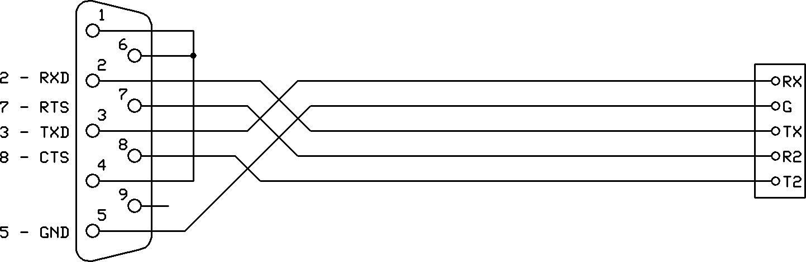
Figure 1 - RS232 Wiring with optional RTS/CTS Handshakes
- SSH70/100 can support two independent RS232 channels. T2/R2 can be used as a second independent pass-through RS232 channel, as per below diagram:
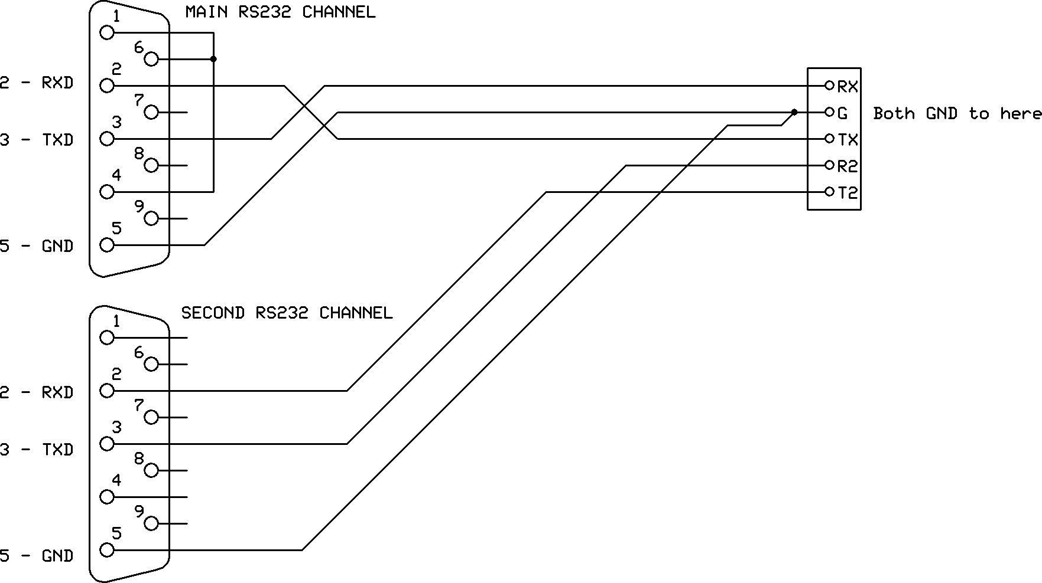
Figure 2 - Dual Independent RS232 Wiring
- If the R2/T2 terminals are not required, they can be left as not connected.

RJ-45 Wiring
Both connectors must be wired identically.
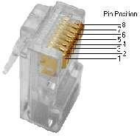 | 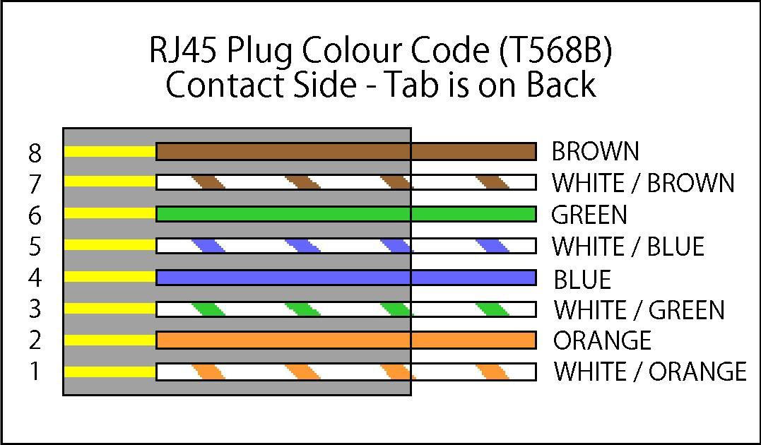
HDBaseT signals will NOT pass through any Ethernet device, the HDBaseT port on the SSH70/100-T must be connected directly to the HDBaseT port on the SSH70/100-R.
Please do make sure that the Cat6 cable uses 4 pairs of 23AWG solid copper wires. Do not use inferior copper clad cables as these exhibit much higher resistances.

Test Pattern and Keep-Alive Features
The SSH70/100 extenders provide a built-in Test Pattern generator for verifying the integrity of connections from the transmitter through to the display device. Several test patterns at different resolutions are provided. See Test Pattern in the RS232 Control Commands section. Test pattern is enabled when the front panel switch on the transmitter is set to TP.
The Video Keep-Alive feature also uses the saved test pattern setting, ensuring a video signal is always present at the receiver HDMI output in the event of input video loss. This mode can also have a timeout value to disable the test pattern after a programmable of time up to 4 hours.
See Video Keep-Alive in the RS232 Control Commands section.

Down-Scaling
The SSH70/100 transmitter can accept 4K50/4K60 4:4:4 (18G) HDMI 2.0 signals. The built-in down-scaler ensures appropriate scaling to maximum HDBaseT bandwidth of 10.2G, whilst providing compatibility with of the display unit. Three scale options are available as per below:
- Down-Scale any 4K resolution to 1080p
- Convert 4K60 4:4:4 signals to 4K60 4:2:0 (colour-space conversion)
- Auto: Provides optimal resolution / colour-space option, based on cable length and display capability.
See 4K Down-Scaling in the RS232 Control Commands section.

Connecting to the IR Ports
The IR IN and IR OUT ports on the rear of the Transmitter/Receiver units may be used to send IR remote control data between the two units. The following table details the wiring connections for the IR input and output ports:
3.5mm Jack Terminal | IR Eye (Receiver) | IR Bud (Emitter)
Tip | 5V | 5V
Ring | IR Signal | Not applicable
Sleeve | Ground | IR Signal

RS232 Control Commands
The many features of SSH70/100 transmitter/receiver units can be managed using RS232 commands (Tx, Rx port). The ASCII commands given in this section use the following port settings:
Baud Rate: 57600
Data Bits: 8
Parity: None
Stop Bits: 1
Notes:
- All commands in this section must be sent in uppercase and are always terminated with the ASCII carriage-return character, 0x0d (represented by the symbol).
- All responses are terminated with the ASCII carriage-return character, 0x0d.
- All spaces shown in the commands are required. Lowercase letters are used as value placement indicators, the required value or identifier is given in the Details panel for the respective command.
- The RS232 commands can be sent to either the SSH70/100-T or SSH70/100-R without regard for the actual unit being controlled. Any command containing TX is always routed to the SSH70/100-T and all RX commands routed to SSH70/100-R.
- All RS232 communications are passed through regardless of baud rate or other settings.
This allows the use of third-party RS232 communication without having to set the protocol specifics – Just pass-through.

SSH70/100-PCTools
SSH70/100-PCTools is a PC software package that allows the user to interface/control the product. Please interface with RS232 (Tx, Rx) port of SSH70/100 (transmitter or receiver) via a com-port (or USB to RS232 dongle). The control panel provides a very simple and easy interface for managing /monitoring the SSH70/100 set. This is highly recommended for installation as well as possible maintenance requirements.
All the following commands, except for the HELP command are included in the SSH70/100-PCTools software.

HELP Command
This command returns the complete list of supported control commands, with examples.
Commands | Command Receive
GET TX HELP | Get the current Transmitter Commands list
GET RX HELP | Get the current Receiver Commands list

Input HDCP Command
The following commands are used to select the HDMI Input HDCP modes.
Commands | Details
SET TX INPUT-HDCP-CONFIG w  (default: 2.2) | w is one of following:  1.4 – Accepts HDCP 1.4 and No HDCP  2.2 – (default) Accepts HDCP 2.2, HDCP 1.4 and No HDCP  OFF – Only accepts signals with No HDCP
GET TX INPUT-HDCP-CONFIG | Get the current input HDCP mode

Output HDCP Command
The following commands are used to select the HDMI Output HDCP modes:
Commands | Details
SET TX HDCP-OPTION w  (default: Follow input) | w is one of following:  FORCE-1.4  FORCE-2.2  FORCE-OFF (cascade mode)  FOLLOW-INPUT (default)
GET TX HDCP-OPTION | Get the output current HDCP mode

EDID Commands
Any of the following pre-defined EDID settings can be selected as the active EDID when the front EDID switch on the SSH70/100-T is set to the PRE position. The selection for PRE is done using the RS232 command given in the following table:
- 4K60-2.0 (default)  - 4K60-5.1  - 4K60-7.1  - 4K30-2.0  - 4K30-5.1  - 4K30-7.1  - 1080P60-2.0  - 1080P60-5.1 | - 1080P60-7.1  - 1080P60-3D-7.1  - 1080P60-DVI  - 1920x1200  - 1680x1050  - 1600x1200  - 1440x900  - 1400x1050 | - 1360x768  - 1280x1024  - 1024x768P60  - 720P60-2.0  - MANUAL  - PASS

Commands | Details
SET TX PREDEFINE-EDID w  (default: 4K60-2.0) | w is one of the 22 EDID options as given above.  See below for use of the MANUAL and PASS options.
GET TX PREDEFINE-EDID | Get the current EDID setting
SET TX COPY-DISP-EDID | Copy Display EDID to the MANUAL EDID memory.
When a specific EDID is required, it is recommended to use SSH70/100-PCTools (select SSH70/100 PCTool from list of tools menu) - load and save the EDID file and then select the MANUAL EDID option by sending the SET TX PREDEFINED-EDID MANUAL command to enable it.
To use the display EDID directly, set the switch on the transmitter to the Pass position, or send the SET TX PREDEFINED-EDID PASS command.

4K Down-Scaling
Compatibility with 1080p display units is assured by down-scaling any 4K (24/25/30/50/60Hz) signal to 1080p. All 1080p or less signals are simply passed through.
For 4K display requirements, 4K60 4:4:4 (or 4K50 4:4:4) input signals can be down-scaled to 4K50/60 4:2:0, ensuring the 10.2Gbps maximum output bandwidth is not exceeded (Max. 40m). All lower bandwidth signals such as 4K30 4:4:4, 1080p are just passed through.
There are three options available:
- 1080p: Down-Scale any 4K signal to 1080p
- 4K60-420: Convert 4K50/60 4:4:4 to 4K50/60 4:2:0 - (colour space conversion)
- Auto: cat5e/6/6a cable and the display capabilities are analysed for optimal resolution / colour space (4K 4:2:0 or 1080p) for 4K50/60 4:4:4 input.
Note: The frame rate is not altered – only the resolution or colour space is changed.
The following command selects the 4K handling mode:
Commands | Details
SET TX 4K-HANDLE w  (default: Auto) | w is one of following options:  1080P  4K60-420  AUTO (default)
GET TX 4K-HANDLE | Get the current 4K handling mode

Video Keep Alive (No Signal Handling) (Timed)
When there is no signal present at the Transmitter (SSH70/100-T), the following options are available:
- Output current Test Pattern – Maintain output video stream (Video Keep-Alive)
- No timing output (default) – (VKA off) No output video; hence video drop-out
- The Test Pattern can be displayed for a programmable time interval
The following commands select the VKA modes:
Commands | Details
SET TX NO-SIGNAL-HANDLE TEST-PATTERN | Output Test Pattern when no input signal
SET TX NO-SIGNAL-HANDLE NO-TIMING | No output when no signal – VKA off (default)
GET TX NO-SIGNAL-HANDLE | Get the current No Signal Handling mode
SET TX VKA-TIMEOUT x  (default: 0 – always on) | x = 0 to 240 minutes (VKA time out)  0 disables the timer and the Video Keep Alive is always on, until an input signal is detected.  Timeout values 1 to 240, will turn off the VKA at the end of period. Values above 240 are ignored (current setting maintained).
GET TX VKA-TIMEOUT | Get the current VKA timeout value.

Test Pattern
SSH70/100 transmitter (SSH70/100-T) has 12 test patterns and 5 resolution settings available. The selected Test Pattern can be activated using the TP switch setting on the transmitter.
Commands | Details
SET TX TEST-PATTERN x y  (default: 1080p Checkerboard) | x is Pattern - select one of following options:  BLACK, RED, GREEN, BLUE, WHITE,  RED_RAMP, GREEN_RAMP, BLUE_RAMP,  PRBS, RAMP, STRIPE, CHECKER-BOARD (default)  y is Resolution - select one of following options:  4K30, 4K25, 4K24, 1080P60, 720P60
GET TX TEST-PATTERN | Get the current Test Pattern mode

Safety Temperature
The following commands can set the Power Off, Warning, and Re-Power temperatures:
Commands | Details
SET TX SAFE-TEMP-ONOFF ON  SET RX SAFE-TEMP-ONOFF ON | Enable Transmitter safety temperature handling  Enable Receiver safety temperature handling
SET TX SAFE-TEMP-ONOFF OFF  SET RX SAFE-TEMP-ONOFF OFF | Disable Transmitter safety temperature handling  Disable Receiver safety temperature handling
SET TX SAFE-TEMP-VALUE x y z  SET RX SAFE-TEMP-VALUE x y z | Set warning temperature x  Set shutdown temperature y  Set re-power temperature z  Default TX settings: x=70, y=75, z=65, the unit is °C  Default RX settings: x=75, y=80, z=70, the unit is °C
GET TX SAFE-TEMP-VALUE  GET RX SAFE-TEMP-VALUE | Get the current Transmitter safety temperature values  Get the current Receiver safety temperature values
Notes:
- For the SAFE-TEMP-VALUE commands, the following rule must be followed:
55 < Re-Power (z) < Warning (x) < Shutdown (y).
- When the device enters the Temperature Warning condition, the red PWR LED will slow flash once every two seconds. When the device enters the power off condition due to excessive overheating, the red PWR LED will fast flash three times a second.
- An automatic GET TX/RX SAFE_TEMP_VALUE RS232 response is reported (sent), in case of Temperature Warning / Power Off condition.

Diagnostic Commands
Diagnostic tools such as Cable Length, Signal Error, Link/Signal Status, Test Pattern, Voltage Values, are most useful during installation, using a PC (or laptop) together with an RS232 interface (or USB to RS232 dongle).
As well as these, other diagnostic commands such as, Input HDMI signal details, Pulse HPD, Temperature values, can be invaluable for overall system fault finding and trouble shooting.
The SSH70/100-PCTools provides an easy and simple way to run these diagnostics efficiently, as well as setting up the special features of SSH70/100 extender set.
Diagnostic Commands | Details
Cable Length
GET TX CABLE-LENGTH | GET TX CABLE-LENGTH wM, w=20,30…70
GET RX CABLE-LENGTH | GET RX CABLE-LENGTH wM, w=20,30…70
Link/Signal Status
GET TX LINK-STATUS | Returns Transmitter link on or link off status
GET RX LINK-STATUS | Returns Receiver link on or link off status
GET TX SIGNAL-STATUS | Returns Transmitter signal on or signal off status
GET RX SIGNAL-STATUS | Returns Receiver signal on or signal off status
Input HDMI Signal Detail
GET TX INPUT-HDMISIGNALS | Get the current input HDMI signals information
Signal Error
GET TX SIGNAL-ERROR | GET TX SIGNAL-ERROR w, w=1, 2, 3…
GET RX SIGNAL-ERROR | GET RX SIGNAL-ERROR w, w=1, 2, 3…
Pulse HPD
SET TX PULL-HPD | Forces HDMI HPD low for 200ms on SSH70/100-T
SET RX PULL-HPD | Forces HDMI HPD low for 200ms on SSH70/100-R
Voltage Values
GET TX SUPPOC-VOLTAGE  GET RX SUPPOC-VOLTAGE | Get the current TX Supply & iPoC Voltages  Get the current RX Supply & iPoC Voltages
Temperature Read
GET TX CPU-TEMP | GET TX CPU-TEMP wC, where w is the temperature (number)  For example, GET TX CPU-TEMP 48C means 48℃
GET RX CPU-TEMP | GET RX CPU-TEMP wC

- Cable Length: cat6 cable length between 20-70m is reported back
- Link Status: Indicates the Transmitter/Receiver units are intercommunicating correctly.
- Signal Status: Indicates video signal activity on HDMI input / Output
- Signal Error: Indicative of cat6 signal line quality
- Input HDMI Signal details: Detailed information about input HDMI video signals, such as: Resolution, Refresh Rate, Colour Depth, HDR Setting, Compressed Audio Setting, Audio Rate, Audio Channels, HBR and HDCP.
- Pulse HPD: This command forces the HDP line low for 200mS, which has a similar effect as HDMI cable disconnection/reconnection.
- Voltage Values: Power supply and iPoC power voltage level measurements are reported.
- Temperature Read: Transmitter and Receiver temperatures closest to the main heat source can be read. This temperature will be higher than the device surface temperature.

CEC Commands
The following group of RS232 commands are only possible with display devices that support CEC commands. Use the Display Connection Status RS232 command to determine the CEC capability when the display device is fully powered.
CEC commands are most useful when it is not practical to use RS232 connection to the display.
CEC Commands | Details
Display On
SET TX DISPLAY-ON | Set Display to the ON state
Display Off
SET TX DISPLAY-OFF | Set Display into the standby state
Volume Increase
SET TX CEC-VOLADD | Increase sound volume
Volume Decrease
SET TX CEC-VOLDEC | Decrease sound volume
Volume Mute
SET TX CEC-MUTE | Mute/Unmute sound volume (Toggle)
Display Connection Status
GET TX READ-DISPLAY | Get the current Connected/Disconnected info
Display Power Status
GET TX DISPLAY-POWER | Get the current display device power on/off info

Automatic CEC Display Control
The following commands set the operating mode for automatic CEC control of the display “power on” and “power off”. The CEC “power off” command can be sent after a specified time delay. The CEC “power on” command will be sent immediately when a new input HDMI signal is detected. To use this feature, the CEC Auto ONOFF must be enabled (ON) (default: OFF)
Commands | Details
SET TX AUTO-ONOFF-CONFIG ON | Enable automatic CEC power on and power off control.
SET TX AUTO-ONOFF-CONFIG OFF | Disable automatic CEC power on and power off control. (default)
SET TX AUTO-OFF-TIMER x  (default: 30 minutes) | x = 1 to 240 minutes.  Values above 240 are ignored (current setting maintained).  Set the time in minutes before sending the CEC power off message, if enabled.

TX POC Commands
These commands set the operation of the Power-Over-Cable (POC) mode of the Transmitter.
Commands | Details
SET TX HDBTPOC ON | The supplied DC voltage is always present on the HDBaseT port.
SET TX HDBTPOC OFF | No power is applied to the HDBaseT port.
SET TX HDBTPOC AUTO | When the Tx is powered from 24V, then the 24V is always sent to the HDBaseT port. (default setting)  When the Tx is powered from 48V, iPoC mode will be used.
SET TX HDBTPOC iPOC | The iPoC mode only outputs a voltage to the HDBaseT port only if an iPoC (SSH70/100) Receiver is detected. It will NOT provide power to any non-iPoC receivers.
GET TX HDBTPOC | Get the TX POC status.

RX POC Commands
These commands set the operation of the Power-Over-Cable (POC) mode of the Receiver.
Commands | Details
SET RX HDBTPOC ON | The supplied DC voltage is always present on the HDBaseT port
SET RX HDBTPOC OFF | No power is applied to the HDBaseT port.
SET RX HDBTPOC AUTO | When the Rx is powered from 24V, then the 24V is always sent to the HDBaseT port. (default setting)  When the Rx is powered from 48V, iPOC mode will be used.
SET RX HDBTPOC iPOC | The iPoC mode only outputs a voltage to the HDBaseT port only if an iPoC (SSH70/100) Transmitter is detected. It will NOT provide power to any non-iPoC transmitters.
GET RX HDBTPOC | Get the RX POC status.

Specifications

General
HDMI Version | Input: HDMI 2.0 - HDR and HBR supported
Max Bandwidth | Input: 18 Gbps (4K60 4:4:4) output: 10.2 Gbps (4K60 4:2:40)
HDCP Compliance | Input HDCP: 1.4 and 2.2  Output HDCP: Fully controlled – Pass, 1.4, 2.2, Cascade mode)
RS232 (Control Commands – Tx, Rx) | 57600 baud, 8 data bits, 1 stop bit, no parity
RS232 (Pass-Through – Tx, Rx) | Any baud rate to maximum of 115200.
RS232 (Pass-Through – T2, R2) | Any baud rate to maximum of 57600. (or use as CTS, RTS)
IR IN, IR OUT | 25-60 KHz carrier frequency

Video and Audio
Input Video Formats Supported | All VESA resolutions to 4096x2160p (18G), and all 3D formats – Examples:  4096x2160p 24/25/30/50/60Hz  3840x2160p 24/25/30/50/60Hz  2560x1440 50/60Hz  2048x1152 50/60Hz  1920x1080p 24/25/30/50/60Hz  1920x1080i 50/60Hz  1280x720p 50/60Hz  All PC resolution including 1920x1200 – Examples:  1920x1200 60/75Hz 1360x768 60/75Hz  1680x1050 60/75Hz 1280x1024 60/75Hz  1600x1200 60/75Hz 1280x960 60/75Hz  1440x900 60/75Hz 1280x800 60/75Hz  1400x1050 60/75Hz 1024x768 60/75Hz  1366x768 60/75Hz 1152x864 60/75Hz
Colour space | RGB, 4:4:4, 4:2:2, 4:2:0
Colour depth | 8, 10, 12 bits
Down-Scaler (output) | 1080p: All 4K inputs scaled down to 1080p  4K60-420: Convert 4K50/60 4:4:4 inputs to 4K50/60 4:2:0
Output Video | Down-scaled signals, with all others as Pass-through video
Audio Formats Supported | 2.0 / 2.1 / 5.1 / 7.1 channel LPCM, Dolby, AC3, DTS
Audio Outputs (de-embed)  (SSH70/100-T) | Mini TosLink (optical)  3.5mm analogue stereo (L/R)

Power Supply
Power Consumption (Tx + Rx) | 9W max. (Tx: 3.5W, Rx: 5.5W)
PSU Rating | 48V @ 0.5A (operating voltage range: 24V to 48V)

Environmental and Physical
Operating Temperature Range | 0 to +40°C (+32 to +104°F)
Operating Humidity Range | 10 to 90 % RH (non-condensing)
Dimensions (L x W x H) | 109 x 74 x 11.5 mm (excluding connectors)
Weight (Unit only) | Transmitter: 165g Receiver: 165g

Package Contents
Item | Qty
SSH70/100-T unit | 1
SSH70/100-R unit | 1
Brackets | 4
5 pin female captive screw connector | 2
IR Emitter / IR Receiver (eye) set | 1
48V DC/0.5A Power Adapter  With interchangeable fittings for UK, EU and US | 1

Notes:
- Heat Management: The SSH70/100 HDBaseT extender has been designed in a revolutionary manner, by directly using the casing as a heatsink for power dissipation. This technique ensures the actual chipsets are running at lower temperatures as the heat generated is dissipated to the environment more efficiently. As a result, the system long term reliability and life-expectancy is significantly improved.
- It is normal for these devices to run hot (in particular the Receiver unit) – Please ensure adequate ventilation and avoid placing them close to any other heat source.
- The SSH70/100 units are also equipped with option of temperature control, thus ensuring that in the event of an excessive temperature rise, the units can safely shut down.

