8x9 UHD HDMI Matrix Switcher

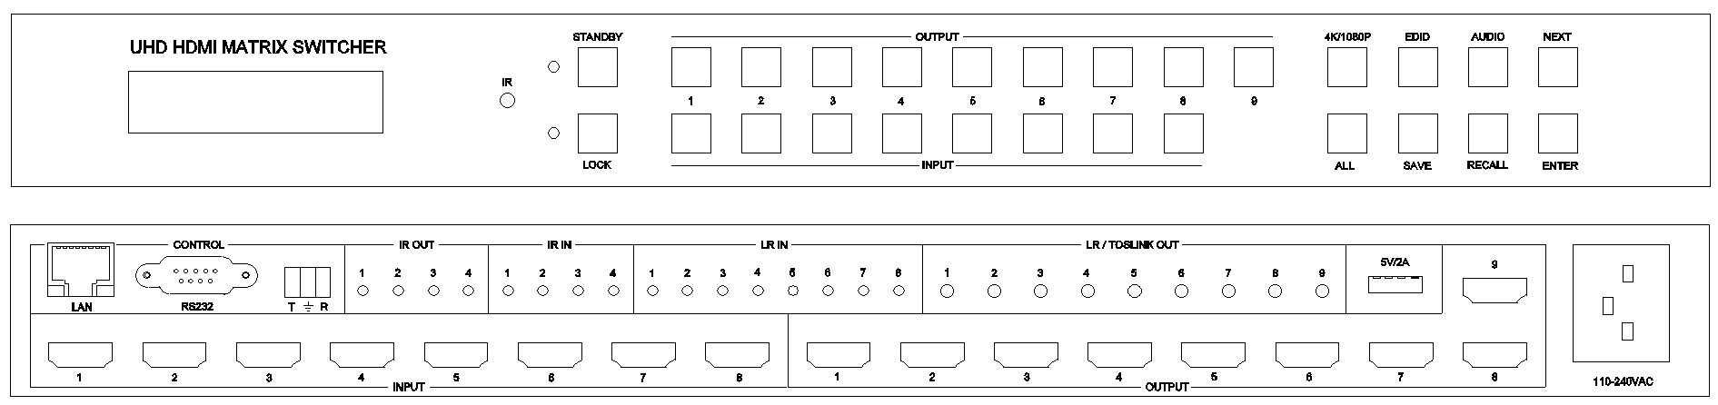

**warning Warning**

* Do not expose this device to Rain, Moisture, and Dripping
* Only use accessories specified by the manufacture
* Unplug this device during Lightning Storms
* Product specifications may be subject to technical upgrades without further notice

Content

Content 2

1 Introduction 3

2 Front Panel 3

3 Rear Panel 4

4 RS232/LAN/Web Control 4

4.1 RS232 connector 4

4.2 Ethernet/Web Control 5

5 Electrical parameters 5

6 Package Contents 5

7 ASCII Commands 5

# Introduction

This device is a high-performance UHD HDMI matrix switcher with 8x HDMI inputs and 9x HDMI outputs. It support audio extract, and external 3.5mm LR input audio can be inserted on corresponding HDMI input stream. The switcher support IR matrix routing for IN1-4 and OUT1-4

Key Features:

* Support HDMI 2.0/HDCP 2.2
* Support HDMI audio extract
* Support external LR audio insert on HDMI stream
* Support IR matrix (Only IN1-4 and OUT1-4)
* Support EDID management
* Support Test Pattern
* Support 4K-HANDLE ( 4K/1080P ) to match different displayer
* Front panel,Remoter,RS232,Ethernet/Web control

# Front Panel

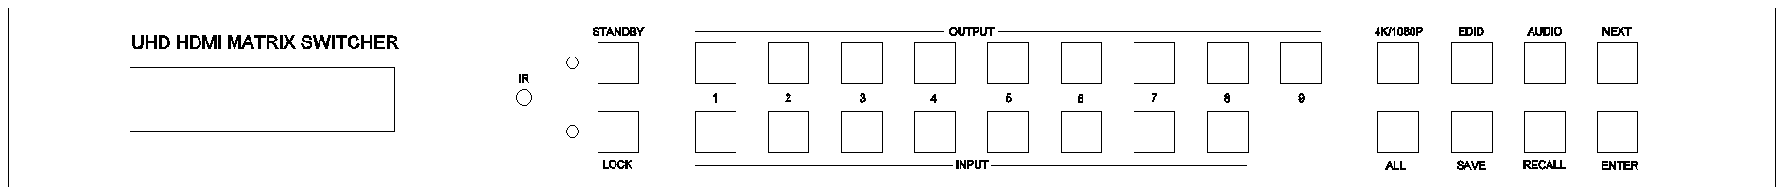

* Press STANDBY and hold for 3 seconds, to make the switcher enter or release standby state.

Press LOCK and hold for 3 seconds to lock or unlock front buttons.

* Press OUTPUT n + INPUT m+ ENTER

Switch matrix input m to output n

* Press ALL + INPUT m + ENTER

Switch input m to all the outputs

* Press button SAVE + OUTPUT n

Save current routing scene as scene n.

The maximum available scene number is 8

* Press RECALL + OUTPUT n

Recall routing scene n as current routing

* Press 4K/1080P + OUTPUT n + NEXT + ENTER

Configure output resolution when 4K input for OUTPUT n.

One of the following option can be selected for each output port

AUTO,PASS, 4:2:0,1080P. Default PASS

AUTO, automatically match the displayer’s capability

PASS, directly pass through the 4K input signal to dispalyer

4:2:0, convert the color space of 4K signal to YUV4:2:0 and output to downstream

1080P, scale the 4K signal down to 1080p and output to downstream

* Press EDID + INPUT m + NEXT + ENTER

Configure EDID mode for INPUT m, please refer to ASCII commands for detail EDID list

* Press AUDIO + INPUT m + NEXT + ENTER

Configure audio selection for INPUT m

Audio selection option for each input port as following:

L/R, EMBEDDED

Please refer rear panel description for detail audio selection

# Rear Panel

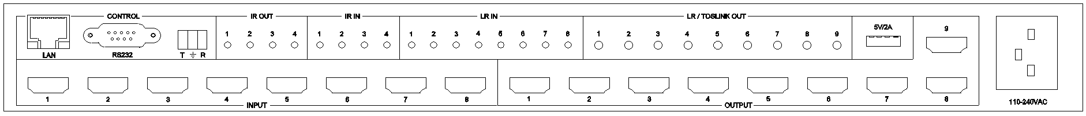

* LAN(10M/100M), RS232 (DB9 and Phoenix connector) are used for PC control
* The 3.5mm analog audio input port are bond to corresponding HDMI input port.

If HDMI 1 audio source is selected with L/R, then analog AUDIO IN LR1 (with ф3.5mm jacket) will be selected to replace the embedded audio of the HDMI input 1 data stream. If HDMI 1 audio source is selected with EMBEDDED, then will use the original embedded audio of input HDMI 1 as its audio data stream. If the input is DVI signal, no matter how it is set up, system will get external analog audio input.

* The 3.5mm LR/Toslink output connector is an analog and digital output compatible interface.

User can get analog LR audio or digital Spdif audio out here.

LR/Toslink audio output will always follow the same audio content with the corresponding HDMI output port.

* Analog Audio IN/OUT connection as following

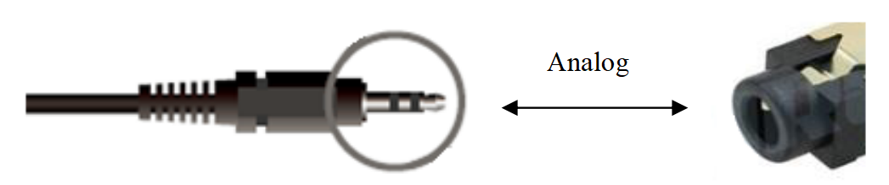

* IR IN and IR OUT (Only IN1-4 and OUT 1-4 supported)
* 5V/2A USB charger port

# RS232/LAN/Web Control

Please refer to ASCII commands

## RS232 connector

* RS-232 (female DB9 or female captive screw connector) control, baud rate 9600
* DB9 RS232 female connector pins layout as following.

|  |  |
| --- | --- |
| Index | Pin |
| 1 | N/u |
| 2 | Tx( Matrix → PC) PC ) |
| 3 | Rx( Matrix **←**PC ) |
| 4 | N/u |
| 5 | Gnd |
| 6 | N/u |
| 7 | N/u |
| 8 | N/u |
| 9 | N/u |

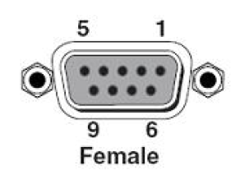

* Phoenix female connector, RS232:

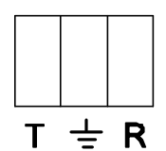

T: Switcher → PC R: Switcher ← PC : Ground

## Ethernet/Web Control

Note：Factory default network setting：

Net Port:23

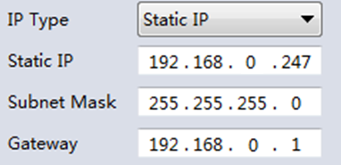

# Electrical parameters

|  |  |
| --- | --- |
| Electrical parameter | |
| Interface | HDMI-A |
| HDMI Version | HDMI2.0,HDCP2.2 |
| Bandwidth | 18Gbps |
| HDMI Amplitude | T.M.D.S +/- 0.4Vpp |
| Differential impedance | 100±15ohm |
| RS232/Ethernet control | |
| Baud rate and protocol | Baud rate：9600, data bit：8， |
| stop bit：1,no parity checking |
| Ethernet | IE10.0+,HTML5 |
| Power | |
| Max Consumption | 60W, 110-240VAC |
| Matrix Mechanical dimensions | |
| Size(mm) | 430(L)X300(W)X44 (H) |
| Weight | 5Kg |
| Operating temperature | 0 to 40°C |
| Storage temperature | -20 to 70°C |
| Permissible humidity | 10%-50% |

# Package Contents

|  |  |
| --- | --- |
| Item | Quantity |
| Switcher | 1 |
| User Manual | 1 |
| AC Power Cord | 1 |
| Remoter | 1 |

# ASCII Commands

Note: All the commands begin with SET or GET, end with Carriage Return (CR).

⮠ Represents Carriage Return (CR).

All return messages are always end with CR.

In the following description, x means input port No.(1,2...,8); y means output port No.(1,2...,9)

|  |  |
| --- | --- |
| System Commands | Details |
| GET SYS HELP⮠ | Get the Commands list |
| SET SYS RESET⮠ | Reset to default setting |
| GET SYS VERSION⮠ | Get system main board firmware version  Return: MAIN VERSION w (w is version number) |
| SET SYS IP STATIC,a,b,c⮠ | Set static IP parameter  a is IP address, b is mask, c is gateway  For example:  Send: SET SYS IP STATIC, 192.168.0.247,255.255.255.0,192.168.0.1⮠  Return: SYS IP STATIC, 192.168.0.247,255.255.255.0,192.168.0.1 |
| SET SYS IP DHCP⮠ | Set dynamic IP parameter  Return: SYS IP DHCP |
| GET SYS IP⮠ | Return : SYS IP STATIC, 192.168.0.247,255.255.255.0,192.168.0.1  or  SYS IP DHCP, 192.168.0.247,255.255.255.0,192.168.0.1 |
| Input/Output Commands | Details |
| SET SAVE SCENE w⮠ | Save current video routing scene to SCENE n  w is 1,2,...8  For example:  Send: SET SAVE SCENE 1  Return: SAVE SCENE 1 |
| SET LOAD SCENE w⮠ | Load/Recall SCENE n as current display scene  w is 1,2,...8  For example:  Send: SET LOAD SCENE 1  Return: LOAD SCENE 1 |
| SET OUTy 4K w⮠ | w is one of the following:  AUTO,PASS,4:2:0,1080P, default PASS  For example  Send: SET OUT1 4K PASS  Return: OUT1 4K PASS |
| GET OUTy 4K⮠ | Return: OUTy 4K w |
| GET OUTy RESOLUTION⮠ | Return: OUTy RESOLUTION w |
| SET OUTy HDCP w⮠ | w is one of FORCE-1.4,FORCE-2.2,FORCE-OFF  Default:FORCE-OFF |
| GET OUTy HDCP⮠ | Return: OUTy HDCP w |
| SET OUTy TSP w⮠ | Set Test Pattern on or off for one output port,  w is ON or OFF  Return: OUTy TSP w |
| GET OUTy TSP⮠ | Return: OUTy TSP w |
| SET OUTy TSP-COLOR w⮠ | Set Test Pattern Colour for one output port ,  w is one of the following:  BLACK,BLUE,GREEN,RED,WHITE, PRBS,RAMP,CHECKER_BOARD,STRIPE, RED_RAMP, GREEN_RAMP, BLUE_RAMP  Default: CHECKER_BOARD  Return: OUTy TSP-COLOR w |
| GET OUTy TSP-COLOR⮠ | Return: OUTy TSP-COLOR w |
| SET OUTy TSP-TIMING w⮠ | Set output timing for Test Pattern display  w is one of 4K60,4K50,4K30,4K25,4K24,1080P60, 720P60  Default 1080P60  Return: OUTy TSP-TIMING w |
| GET OUTy TSP-TIMING⮠ | Return: OUTy TSP-TIMING w |
| SET OUTy VKA w⮠ | Set output mode for one output port when no signal input, w is TSP or NO-TIMING  Default NO-TIMING  TSP means Test Pattern  Return: OUTy VKA w |
| GET OUTy VKA⮠ | Return: OUTy VKA w |
| SET INx VIDEO OUTy⮠ | x is 1,2...or 8; y is 1,2,...9 or ALL  Return: INx VIDEO OUTy |
| SET INx VIDEO OUTy1,y2,y3...⮠ | Set one input to several outputs  Up to 8 outputs can be selected meanwhile here |
| GET OUTy VIDEO⮠ | Get the information about the input source number for one output port  Send: GET OUT1 VIDEO⮠  Return:OUT1 VIDEO IN1 |
| GET OUTy HPD⮠ | Return: OUTy HPD ON or OFF |
| SET PREVIEW OUTy⮠ | Set preview function on OUTy, y is 0,1,2...8 or 9  When y is 0, means no preview function  When OUTy is set as a preview port, it always show the last valid image, when current image lost with OUTy, the next source priority sequence which displayed on OUTy will be IN1,2...8 which is signal valid |
| GET PREVIEW OUT⮠ | Return: PREVIEW OUTy⮠ |
| GET INx IN-SIGNAL⮠ | For example  Return: IN1 RESOLUTION 3840x2160p60 |
| SET COLOR-UNIFY w⮠ | Unify input color space to RGB  w is ON or OFF, default OFF  Return: COLOR-UNIFY OFF  This command needs to take effect after re-power the switch |
| SET INx AUDIO w⮠ | Set audio selection for one input port  w is L/R or EMBEDDED |
| GET INx AUDIO⮠ | Return: INx AUDIO w |
| SET OUT-AUDIOz OUTy⮠ | Set audio output 1 or output 2 on rear panel binding relationship with HDMI output port  z is 1 or 2; y is 1,2...8 or 9 |
| GET OUT-AUDIOz⮠ | Return: AUDIOz OUTy |
| EDID Commands | Details |
| SET INx EDIDMODE w⮠ | x is 1,2...,8, w is one of the following:  4K60-2.0, 4K60-5.1, 4K60-7.1, 4K30-2.0,  4K30-5.1, 4K30-7.1, 1080p60-2.0,1080p60-5.1,  1080p60-7.1,1920x1200, 1680x1050, 1600x1200, 1440x900, 1360x768, 1280x1024, 1024x768, 720p, 3440x1440, 2560x1600, USER  Default: 4K60-2.0  Return: INx EDIDMODE w |
| GET INx EDIDMODE⮠ | Return: INx EDIDMODE w |
| SET INx EDID-USER w⮠ | Switcher can support 256 bytes EDID-USER data.  x is 1,2...8, w is 256 bytes EDID data.  Return: INx EDID-USER OK |
| CEC Commands | Details |
| SET SYS AUTO-POWERON ON w⮠ | w is ON or OFF  This command to Enable/Disable Auto Power function to control sources and displayers by CEC |
| GET SYS AUTO-POWERON⮠ | Return: SYS AUTO-POWERON ON⮠ |
| SET OUTy POWER w⮠ | y is 1,2...8 or 9, w is ON or OFF  Set CEC command to power on or power off display device |
| SET OUTy AUDIO VOLUME+⮠ | y is 1,2...8 or 9  Return: OUTy AUDIO VOLUME+⮠ |
| SET OUTy AUDIO VOLUME-⮠ | y is 1,2...8 or 9  Return: OUTy AUDIO VOLUME-⮠ |
| SET OUTy AUDIO MUTE⮠ | Return: OUTy AUDIO MUTE⮠  This CEC command will toggle MUTE/UNMUTE |