Ultra HD Video Scaler

Model No. LY1601

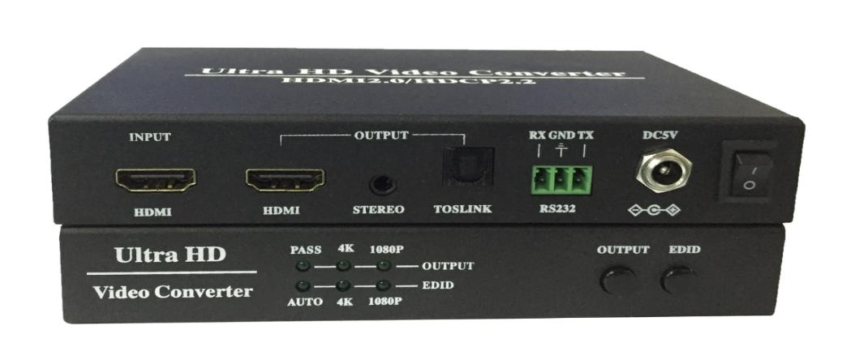

- Support HDMI2.0/HDCP2.2/18Gbps
- 4K UHD down-scale to 1080p.
- 1080p up-scale to 4K.
- Audio extracted and output with 3.5mm Jack and Toslink.

Warning

- Do not expose this box to Rain, Moisture, and Dripping.
- Only use accessories specified by the manufacture.
- Unplug this box during Lightning Storms.
1. Introduction

LY1601 Ultra HD Video Scaler box supports up-scale 1080p to 4K, down-scale 4K to 1080p.
For non-4K and non-1080p, it will bypass input to output.
It’s able to extracts audio from HDMI input and output with 3.5mm Jack and Toslink.

2. Front Panel, Buttons and LEDs



OUTPUT button: select output resolution between PASS, 4K, 1080P.
*1. PASS: bypass input with any formats to output.
*2. 4K: only works with 1080p input. It will up-scale 1080p to 4K.
*3. 1080p: only works with 4K input. It will down-scale 4K to 1080p.
*4. Frame rate conversion is not supported.

EDID button: select AUTO, 4K, 1080P
*1. AUTO: It will automatically copy the EDID data from display devices.
*2. 4K: Force the EDID to 4K.
*3. 1080p: Force the EDID to 1080p.

3. Back Panel

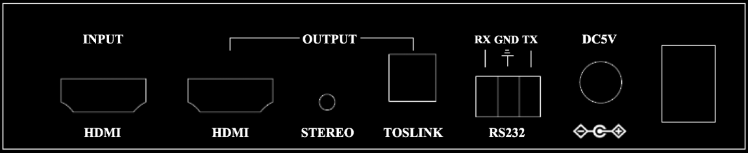

*1. RS232 Phoenix Connector is only for firmware upgrade

4. Specifications
Operating Temperature Range | 0 ºC ~ 40ºC
Storage Temperature | -20 ºC ~ 60ºC
Input / Output HDMI Format | Up to HDMI 2.0/HDCP2.2/18Gbps, 4:4:4 60Hz.
Power | 3watts (Max), 5V/1.5A power adapter
Main Unit Dimensions (L*H*W) | 143mm×83mm×26mm
Main Unit Weight | 0.35kg
Package Size (L*H*W) | 220mm×196mm×54mm

5. Package Contents
- LY1601 Ultra-HD Video Scaler 1pcs
- User Manual 1pcs
- Power Supply, 5V/1.5A 1pcs

6. Appendix, LY1601 input/output resolution

Scale up |  | Scale down
In | Out | In | Out
1080p24 | 3840x2160/24 | 3840x2160/24 | 1080p24
1080p25 | 3840x2160/25 | 3840x2160/25 | 1080p25
1080p30 | 3840x2160/30 | 3840x2160/30 | 1080p30
1080p50 | 3840x2160/50 | 3840x2160/50 | 1080p50
1080p60 | 3840x2160/60 | 3840x2160/60 | 1080p60
 |  | 4096x2160/24 | 1080p24
 |  | 4096x2160/25 | 1080p25
 |  | 4096x2160/30 | 1080p30
 |  | 4096x2160/50 | 1080p50
 |  | 4096x2160/60 | 1080p60

Resolution supported for passthrough
3840x2160/24 | 480i | 1080P30 | 1360*768/60/75
3840x2160/25 | 576i | 1080P50 | 1400*1050/60/60RB
3840x2160/30 | 480p | 1080P60 | 1440*900/60/60RB
3840x2160/50 | 576p | 640*480/75 | 1680*1050/60
3840x2160/60 | 720p50 | 800*600/60/75 | 1920*1200/60RB
4096x2160/24 | 720p60 | 1024*768/60/75 | 1600*900/60RB
4096x2160/25 | 1080i50 | 1280*768/60/75
4096x2160/30 | 1080i60 | 1280*800/60/75
4096x2160/50 | 1080P24 | 1280*960/60/75
4096x2160/60 | 1080P25 | 1280*1024/60/75

