DVI-Universal Video Converter

Model No.LY1603

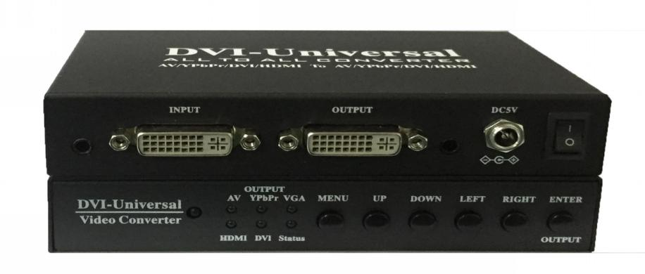

Features

- All to All Converter: support any of AV/YPbPr/VGA/DVI/HDMI to convert to any of AV/YPbPr/VGA/DVI/HDMI.
- Output with up to 14 kinds of resolution.
- Menu control on screen display.
- Attached DVI-YPbPr, DVI-HDMI, and DVI-VGA adapter in the package.
- Auto indentification with input video format (such as CVBS, YPbPr).

Warning

- Do not expose this box to Rain, Moisture, and Dripping.
- Only use accessories specified by the manufacture.
- Unplug this box during Lighting Storms.

Introduction

LY1603 Convert box converts any input of CVBS, YPbPr, VGA, DVI or HDMI to any output of CVBS, YPbPr, VGA, DVI or HDMI.
User can use front button to select output format (CVBS, YPbPr, VGA, DVI or HDMI), also can use bottom Dial Switch to select output resolution (1080p, 720p, etc.).
User can use front buttons to show Menu Navigation and adjust picture position, picture mode, and input source.

Front Panel and User Menu

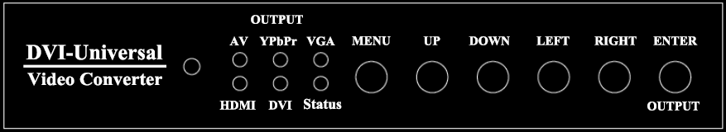

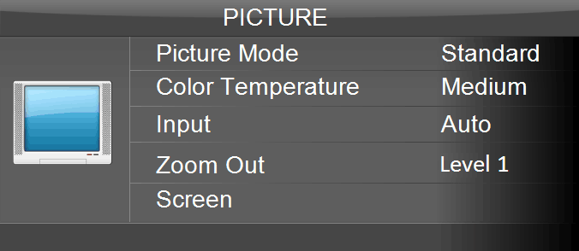

“Screen” adjusts only available when VGA input.
“Zoom Out” adjust only available when AV output.
User can select input source with “Auto” or specified AV, YPbPr, VGA, HDMI.
When no Menu on the screen, user can use “Enter/Output” button on the
front panel to select Output format, Such as AV, YPbPr, VGA, DVI or HDMI

Back Panel

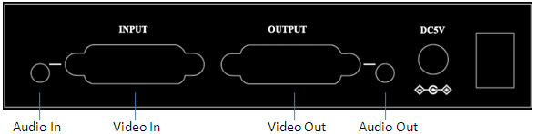

Bottom Panel and Dial Switch

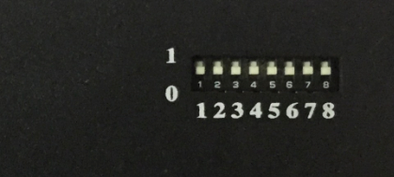

HDMI/DVI/VGA output |  |  |  |  |  |  | YPbPr output |  |  |  | CVBS output
Switch |  |  |  | resolution |  |  | Switch |  |  | resolution | Switch | resolution
1 | 2 | 3 | 4 |  |  |  | 5 | 6 | 7 | resolution | 8 | resolution
0 | 0 | 0 | 0 | 1920x1080 60HZ | VGA | HDMI  DVI | 0 | 0 | 0 | 1080P 60HZ | 0 | PAL
0 | 0 | 0 | 1 | 1280x720 60HZ | VGA | HDMI  DVI | 0 | 0 | 1 | 720P 60HZ | 1 | NTSC
0 | 0 | 1 | 0 | 1024x768 60HZ | VGA | HDMI  DVI | reserved |  |  | reserved | reserved | reserved
0 | 0 | 1 | 1 | 1280x1024 60HZ
0 | 1 | 0 | 0 | 1360x768 60HZ
0 | 1 | 0 | 1 | 1440x900 60HZ
0 | 1 | 1 | 0 | 1600x1200 60HZ
0 | 1 | 1 | 1 | 1680x1050 60HZ
1 | 0 | 0 | 0 | 1920x1080 50HZ
1 | 0 | 0 | 1 | 1280x720 50HZ
1 | 0 | 1 | 0 | 1280x800 60HZ
1 | 0 | 1 | 1 | 1366x768 60HZ
1 | 1 | 0 | 0 | 1400x1050 60HZ
1 | 1 | 0 | 1 | 1920x1200 60HZ

\

System connection
User can use DVI-YPbPr/CVBS, DVI-HDMI, DVI-VGA adapter or cable to setup connection between source device and LY1603 convert box or between LY1603 convert box and Sink device such as TV, Projector

Adapters

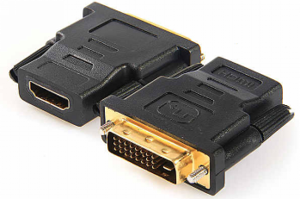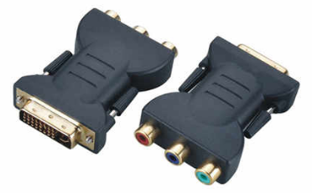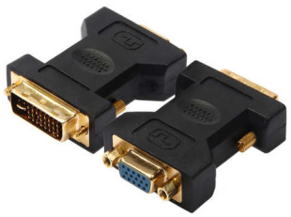

Cables

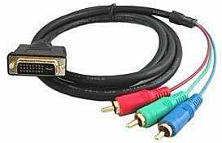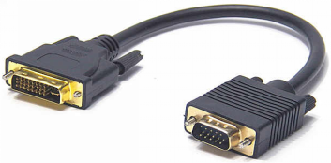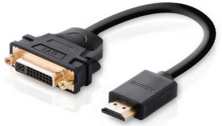

Accessories
Main unit, LY1603 convert box
User Manual
Power Supply, 5V/1.5A
Adapters 3pcs

Specifications
Operating Temperature Range | 0 to +70°C
HDMI Format Supported | HDMI 1.3, up to 1080p
Power | 3wtts (Max), 5V/1.5A power adapter
Main Unit Dimensions (L*W*H) | 143mm×83mm×26mm
Main Unit Weight | 0.35kg
Package Size (L*W*H) | 220mm×196mm×54mm

